# Using the auditoryResponseTester

Fundamental frequency response experiment procedure (still editing)

April 6, 2021

Hideki Kawahara

Table of Contents

Using the auditoryResponseTester 1

Purpose of the experiment 1

Circumstances under which the experiment will be conducted 2

Equipment used for experiments 2

Equipment used in the example 2

Connection and placement of equipment 3

installation 5

If you have MATLAB and Audio Toolbox 5

If you don't have the Audio Toolbox 5

Operation Procedure 6

starting up (e.g. business, computer) 6

Sensitivity calibration of the recording system 7

Notes on calibration 8

Cleaning up after calibration 11

Measurement of fundamental frequency response 11

Record and analyze experimental results 12

Confirmation of presented sound pressure 13

## Purpose of the experiment

To measure the response of the fundamental frequency of the voiced voice to the frequency modulation of the fundamental frequency of the sound heard during the production of a sustained vowel.

## Circumstances under which the experiment will be conducted

The measurement will be conducted in a room where dark noise is not high (sound pressure level measured by A characteristic is less than 40 dB). Auditory stimuli will be recorded using noise-canceling headphones, and speech will be recorded using an omnidirectional condenser microphone near the lips.

## Equipment used for experiments

* PC: Mac or Windows machine

* OS: macOS (experimental software developed by Big Sur)

Windows 10

* Audio Interface

Microphone input (assuming condenser microphone. (48V Phantom if necessary)

AUX input

Two line-level output channels

* Active speaker or amplifier and speaker

* Sealed Noise-Canceling Headphones

Noise-canceling not essential in preliminary experiments

* Omni-directional condenser microphone for proximity recording

## Equipment used in the example

* PC: MacBookPro (13-inch, 2018, Four Thunderbolt 3 Ports)

2.7 GHz quad-core Intel Core

i716 GB 2133 MHz LPDDR3

* OS: macOS Big Sur 11.2.3

* Audio Interface

ROLAND Rubix24

* Speaker

IK Multimedia iLoud Micro Monitor

* Headphones

SONY MDR-1RNC

* Microphone

SHURE MX153T/O-TQG + RK100PK

## Connection and placement of equipment

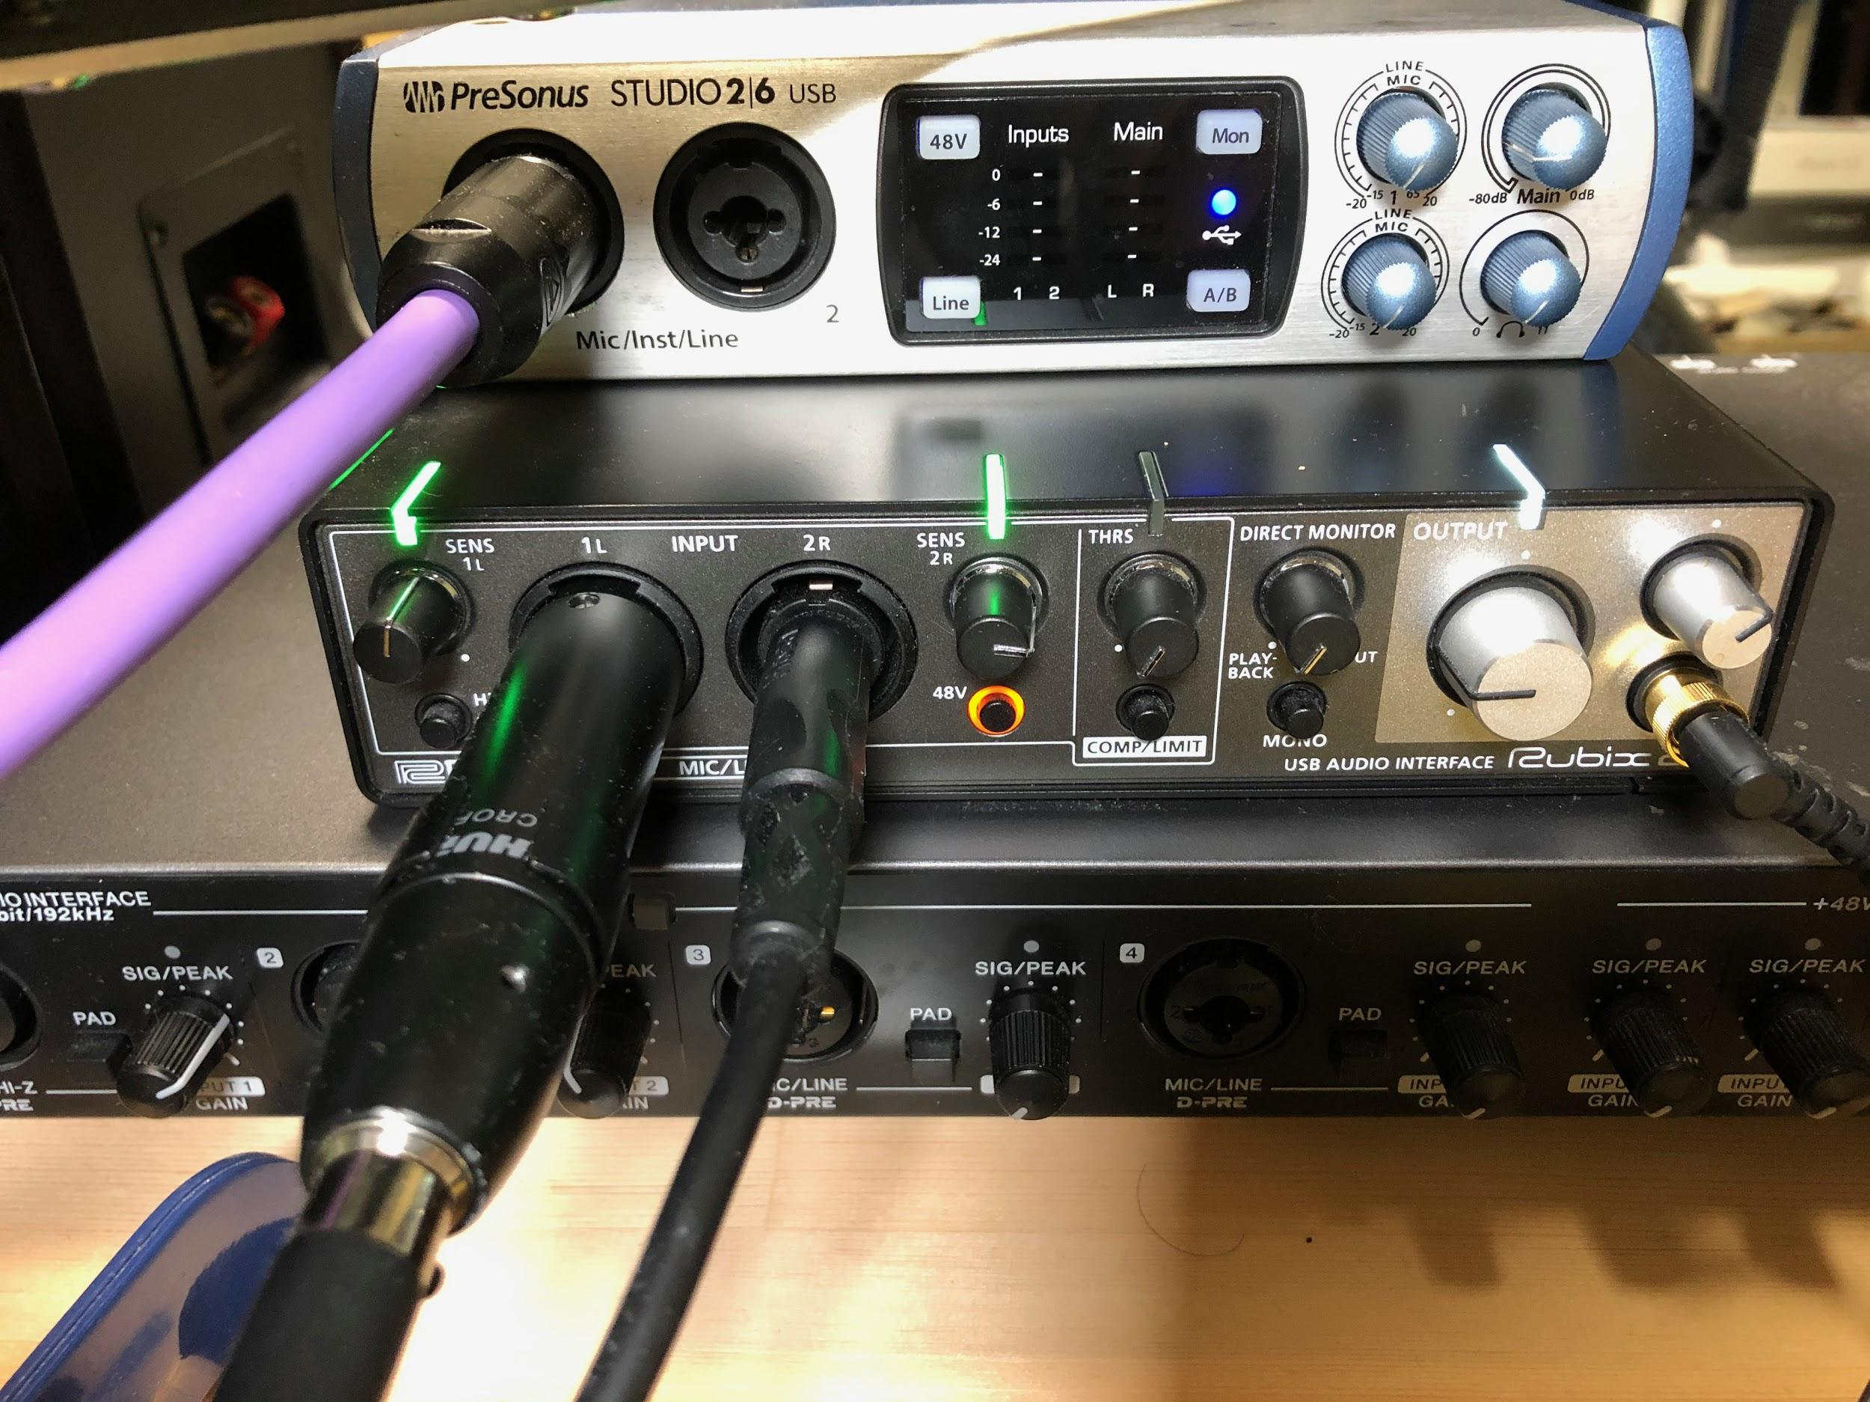

The middle row is the audio interface.

* A condenser microphone is connected to the input terminal labeled "1L" via a head amplifier (RK100PK).

* The LINE input marked "2R" (unbalanced phone plug) is connected to the 2R LINE output of the audio interface.

* LINE output 1L is connected to the left channel of the active speaker.

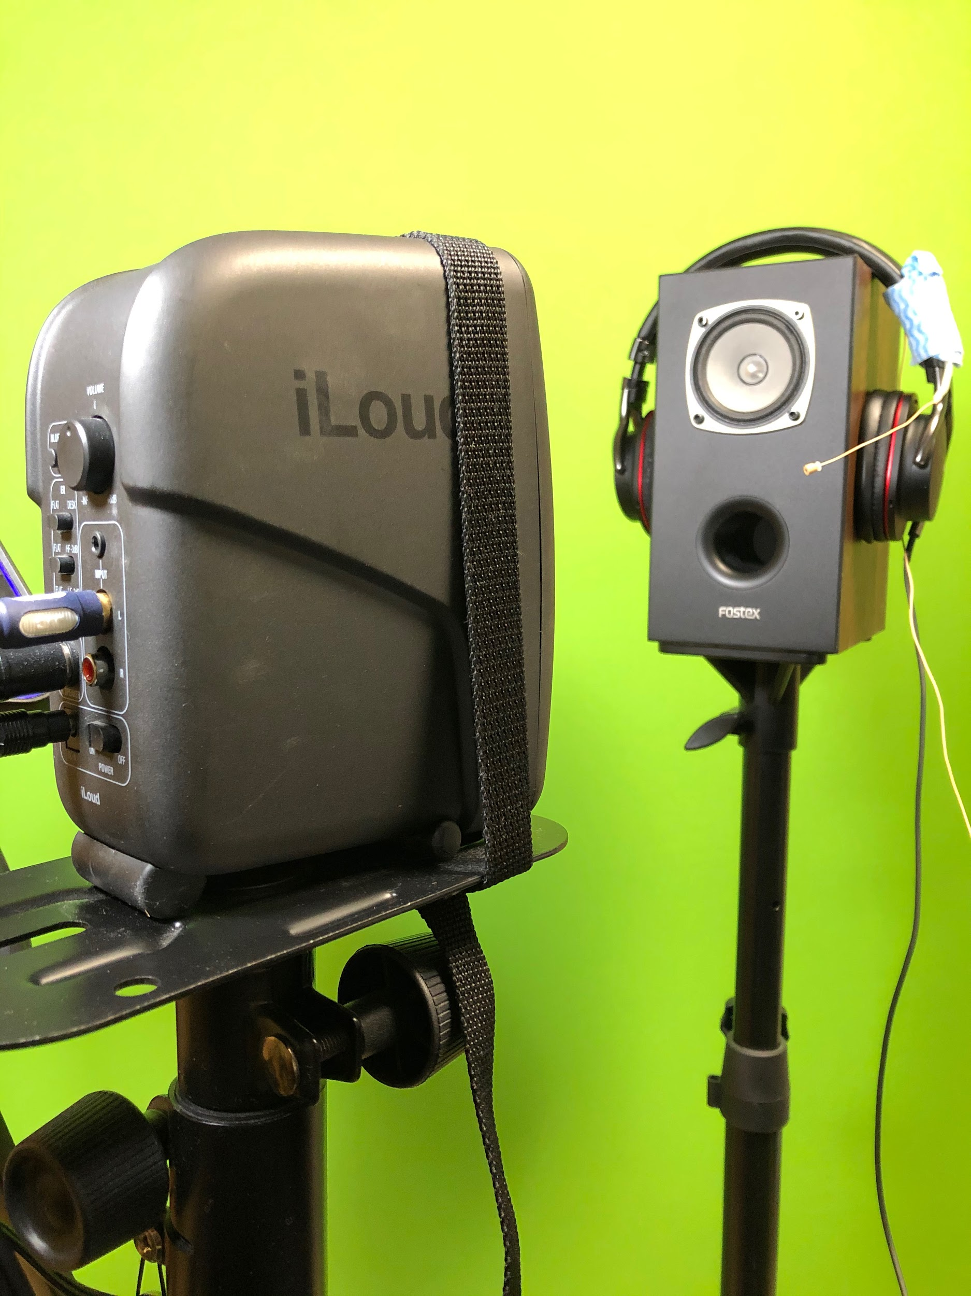

Assume that the speaker on which the headphones are hung is the human head, and the bass reflex port is the opening of the mouth. The distance between the microphone and the center of the aperture should be about 4 to 10 cm. In this experiment, it is recommended to take pictures from several directions so that the distance can be measured. The speaker is used for sensitivity calibration of the recording system and (in this experiment) for the experimenter to confirm that the sound is being presented.

## installation

### If you have MATLAB and Audio Toolbox

Download the folder named "auditoryResponseTestTool" from Google drive at the following link.

<https://drive.google.com/drive/folders/1RIGYso31cajxiuiuQdADppWgMYC7dVe6?usp=sharing>

### If you don't have the Audio Toolbox

We have created MATLAB-independent applications for macOS and Windows 10, and prepared an installer. This installer prepares an environment to execute MATLAB instructions so that the application can be run on a machine without MATLAB installed.

#### For macOS

Download the folder named MyAppInstaller_web.app from Google drive at the following link.

<https://drive.google.com/drive/folders/1RIGYso31cajxiuiuQdADppWgMYC7dVe6?usp=sharing>

In the case of macOS, the downloaded file appears as an application as shown below. Here, I put it on my desktop.

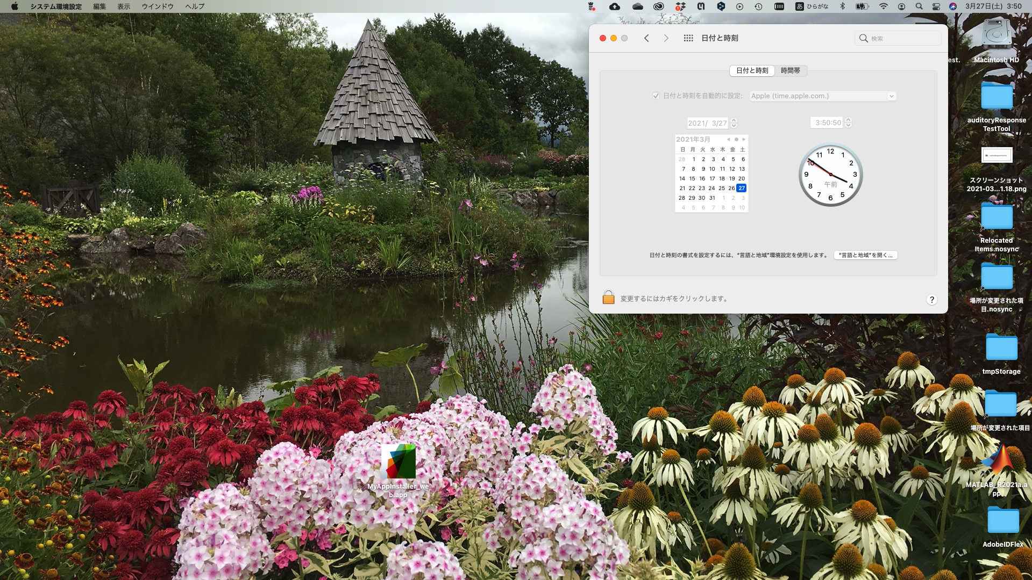

Click on this icon to start the installation. A 7-minute movie of the 25 minutes from installation to operation test is placed in the same folder. The direct link is the first 3 minutes and 20 seconds of the installation, and the rest of the movie is the operation test. See below. A clock is placed at the edge of the screen, so you can see how long it actually took.

<https://drive.google.com/file/d/1sjHw9tIpyiV-NVkL9m0AaXxkA1Nmz8H6/view?usp=sharing>

The first time you run the program after installation, it will take a very long time because of the internal configuration required for execution. The next time you run the program, the time will be reduced because the settings will be reused. As shown in the last part of the movie, it is useful to create an alias and put it on your desktop.

#### For Windows

Download the application (installer) named auditoryResponseTester.exe from the Google drive at the following link.

<https://drive.google.com/drive/folders/1RIGYso31cajxiuiuQdADppWgMYC7dVe6?usp=sharing>

Click on this application to start the installation. The installer will download and install the 800MB+ environment from Mathrorks if you do not have the MATLAB environment on your machine. If the MATLAB environment already exists (for example, because it was installed previously), the tool application will be downloaded and installed. In this case, it will take less than a few minutes. When installing, it is recommended to check the "Create shortcut on desktop" checkbox in the dialog to confirm the installation location.

The following is a movie of the installation procedure on a machine that already has a MATLAB execution environment. In this movie, I am checking the operation of the application. The whole movie is about 3 minutes long, so I have not edited it.

<https://drive.google.com/file/d/1mGIQI4AdMVYZnh9XJ0ejZ49CvjVHmYuR/view?usp=sharing>

## Operation Procedure

After 3 minutes and 30 seconds of the installation movie, it is the same for both MATLAB+Audio Toolbox and MATLAB-independent applications. However, in the case of non-dependent applications, it may take extra time for the state transition. The main operations are explained below.

### starting up (e.g. business, computer)

In the case of MATLAB+Audio Toolbox, use the command window to select the

auditoryResponseTester

and press return.

For the MATLAB-independent version, click on the (alias) icon.

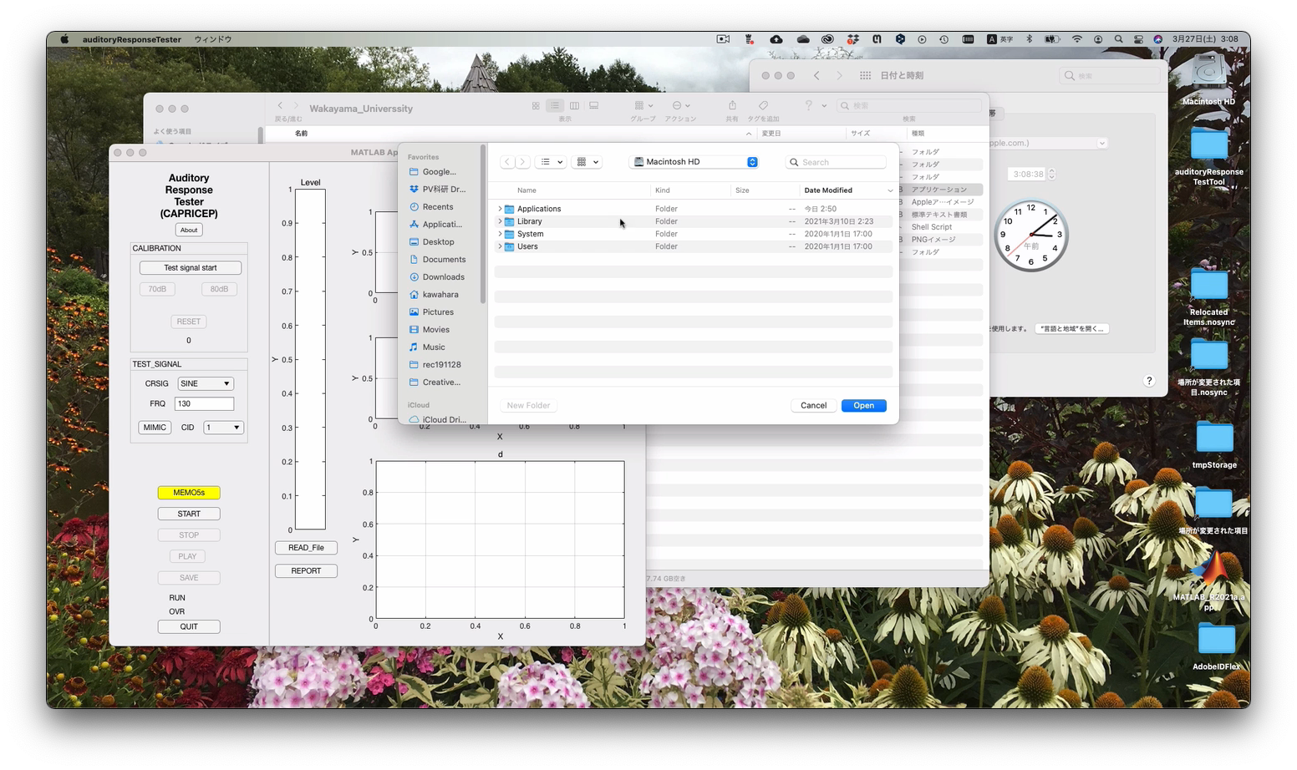

First, you will be asked to specify a directory to record the results of the experiment and the log. Specify an appropriate directory.

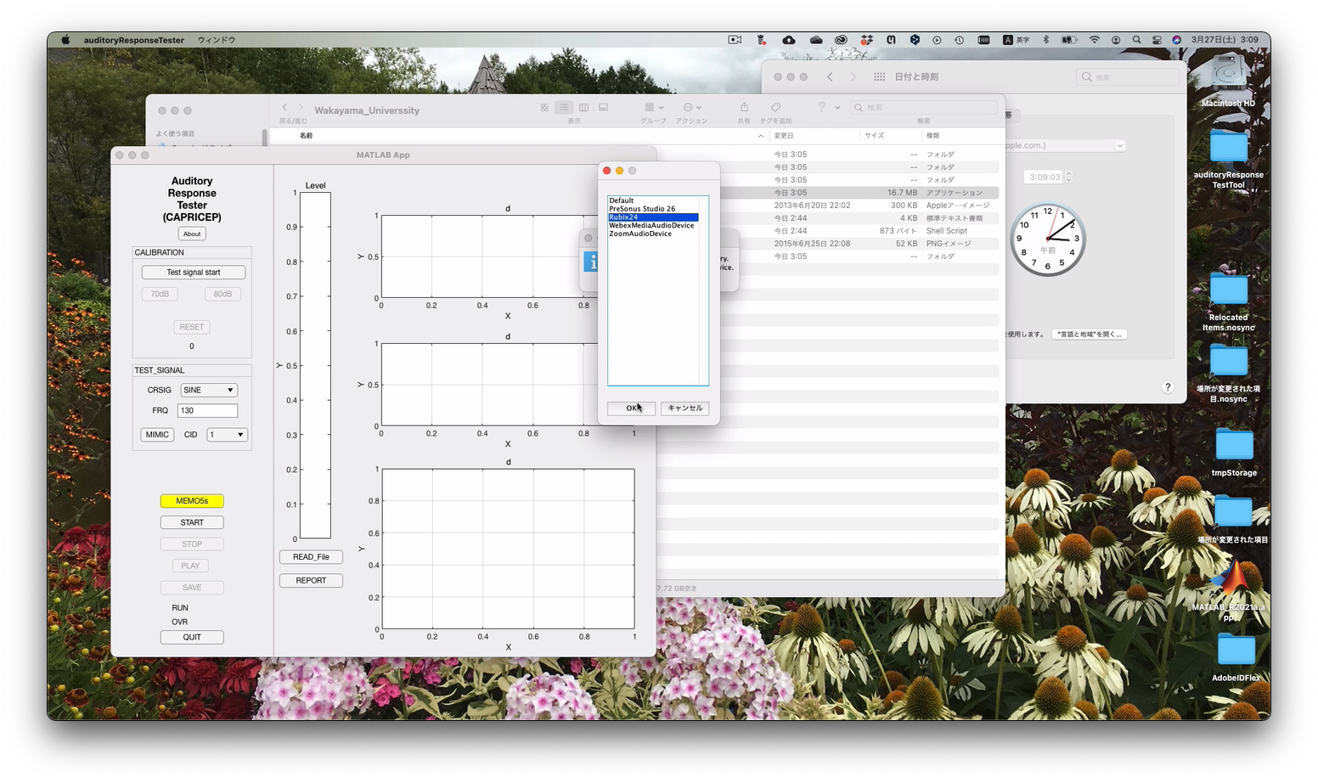

Next, you will be asked to specify the audio interface to be used. In this case, I specified Rubix24.

### Sensitivity calibration of the recording system

The next step is to calibrate the sensitivity of the recording system.

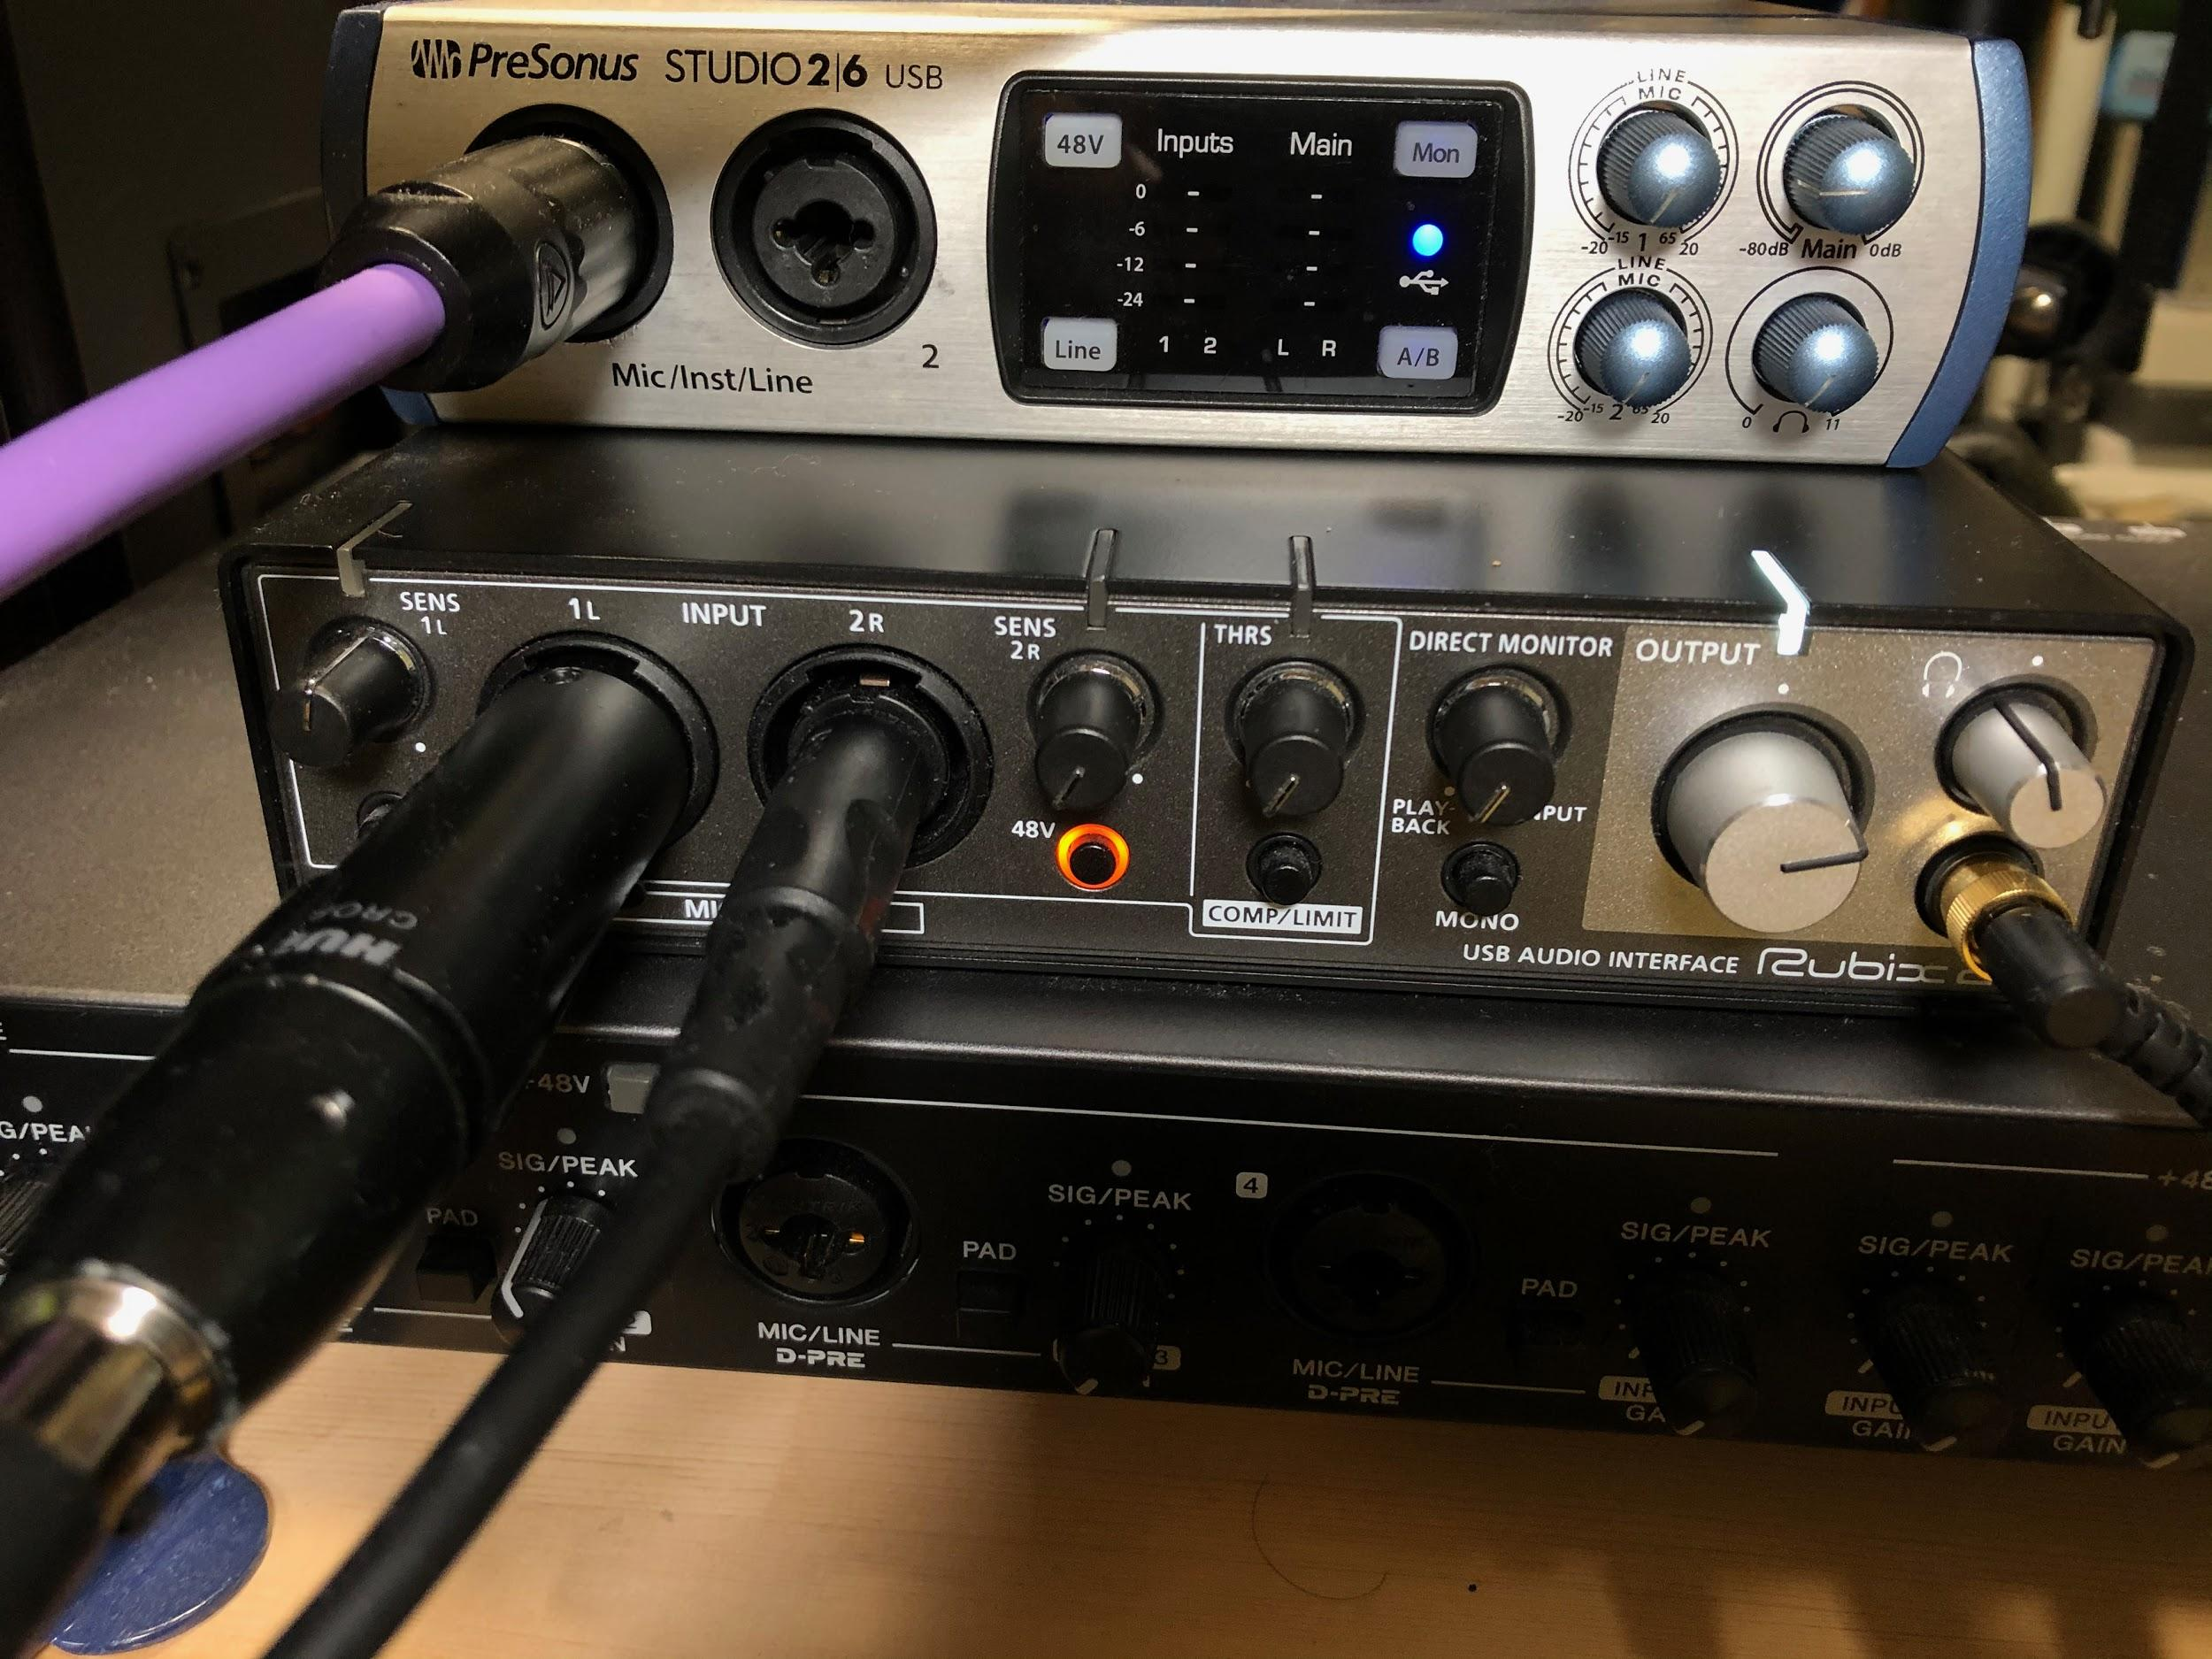

Before using the GUI, put on the headphones and microphone as you would in a real experiment, make the loudest noise you plan to make in the experiment, and adjust the 1L input knob so that the sensitivity is as high as possible without causing excessive input (on the Rubix24, the LED above the input terminal glows green and not red). Set the sensitivity to be as high as possible. After that, do not operate the 1L input level knob.

### Notes on calibration

Since the calibration will produce a loud sound, the input sensitivity of 2R should be set to minimum (turned fully to the left).



Next, as shown in this picture, set up the microphone appropriately and set up a speaker nearby. After making these preparations, press the "Test sound start" button on the GUI.

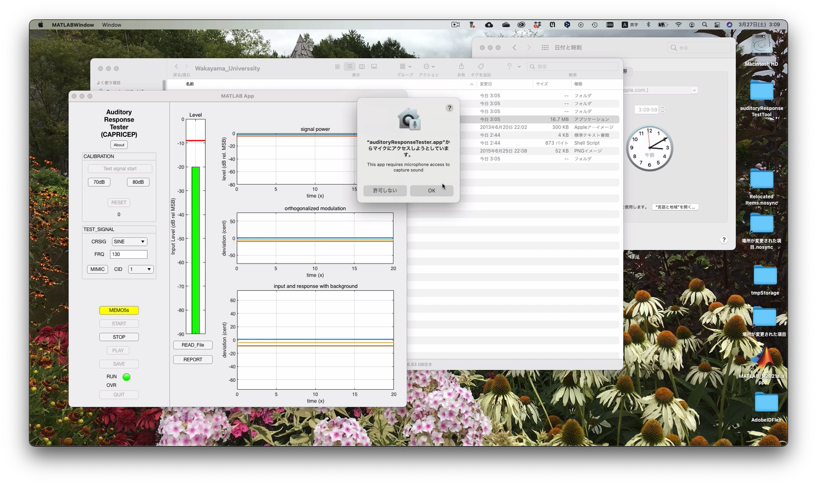

On the first run after installing the MATLAB-independent version, you will be asked if you want to allow access to the microphone, as shown in this image. Since we need access to the microphone for this experiment, we click "OK" to allow it. After a few moments, you will start to hear noise. At this point, use the "OUTPUT" knob on the audio interface to adjust the sound pressure level at the microphone position to 80 dB on the A characteristic. Check the sound pressure level at the microphone position by using a noise system as shown in the picture.

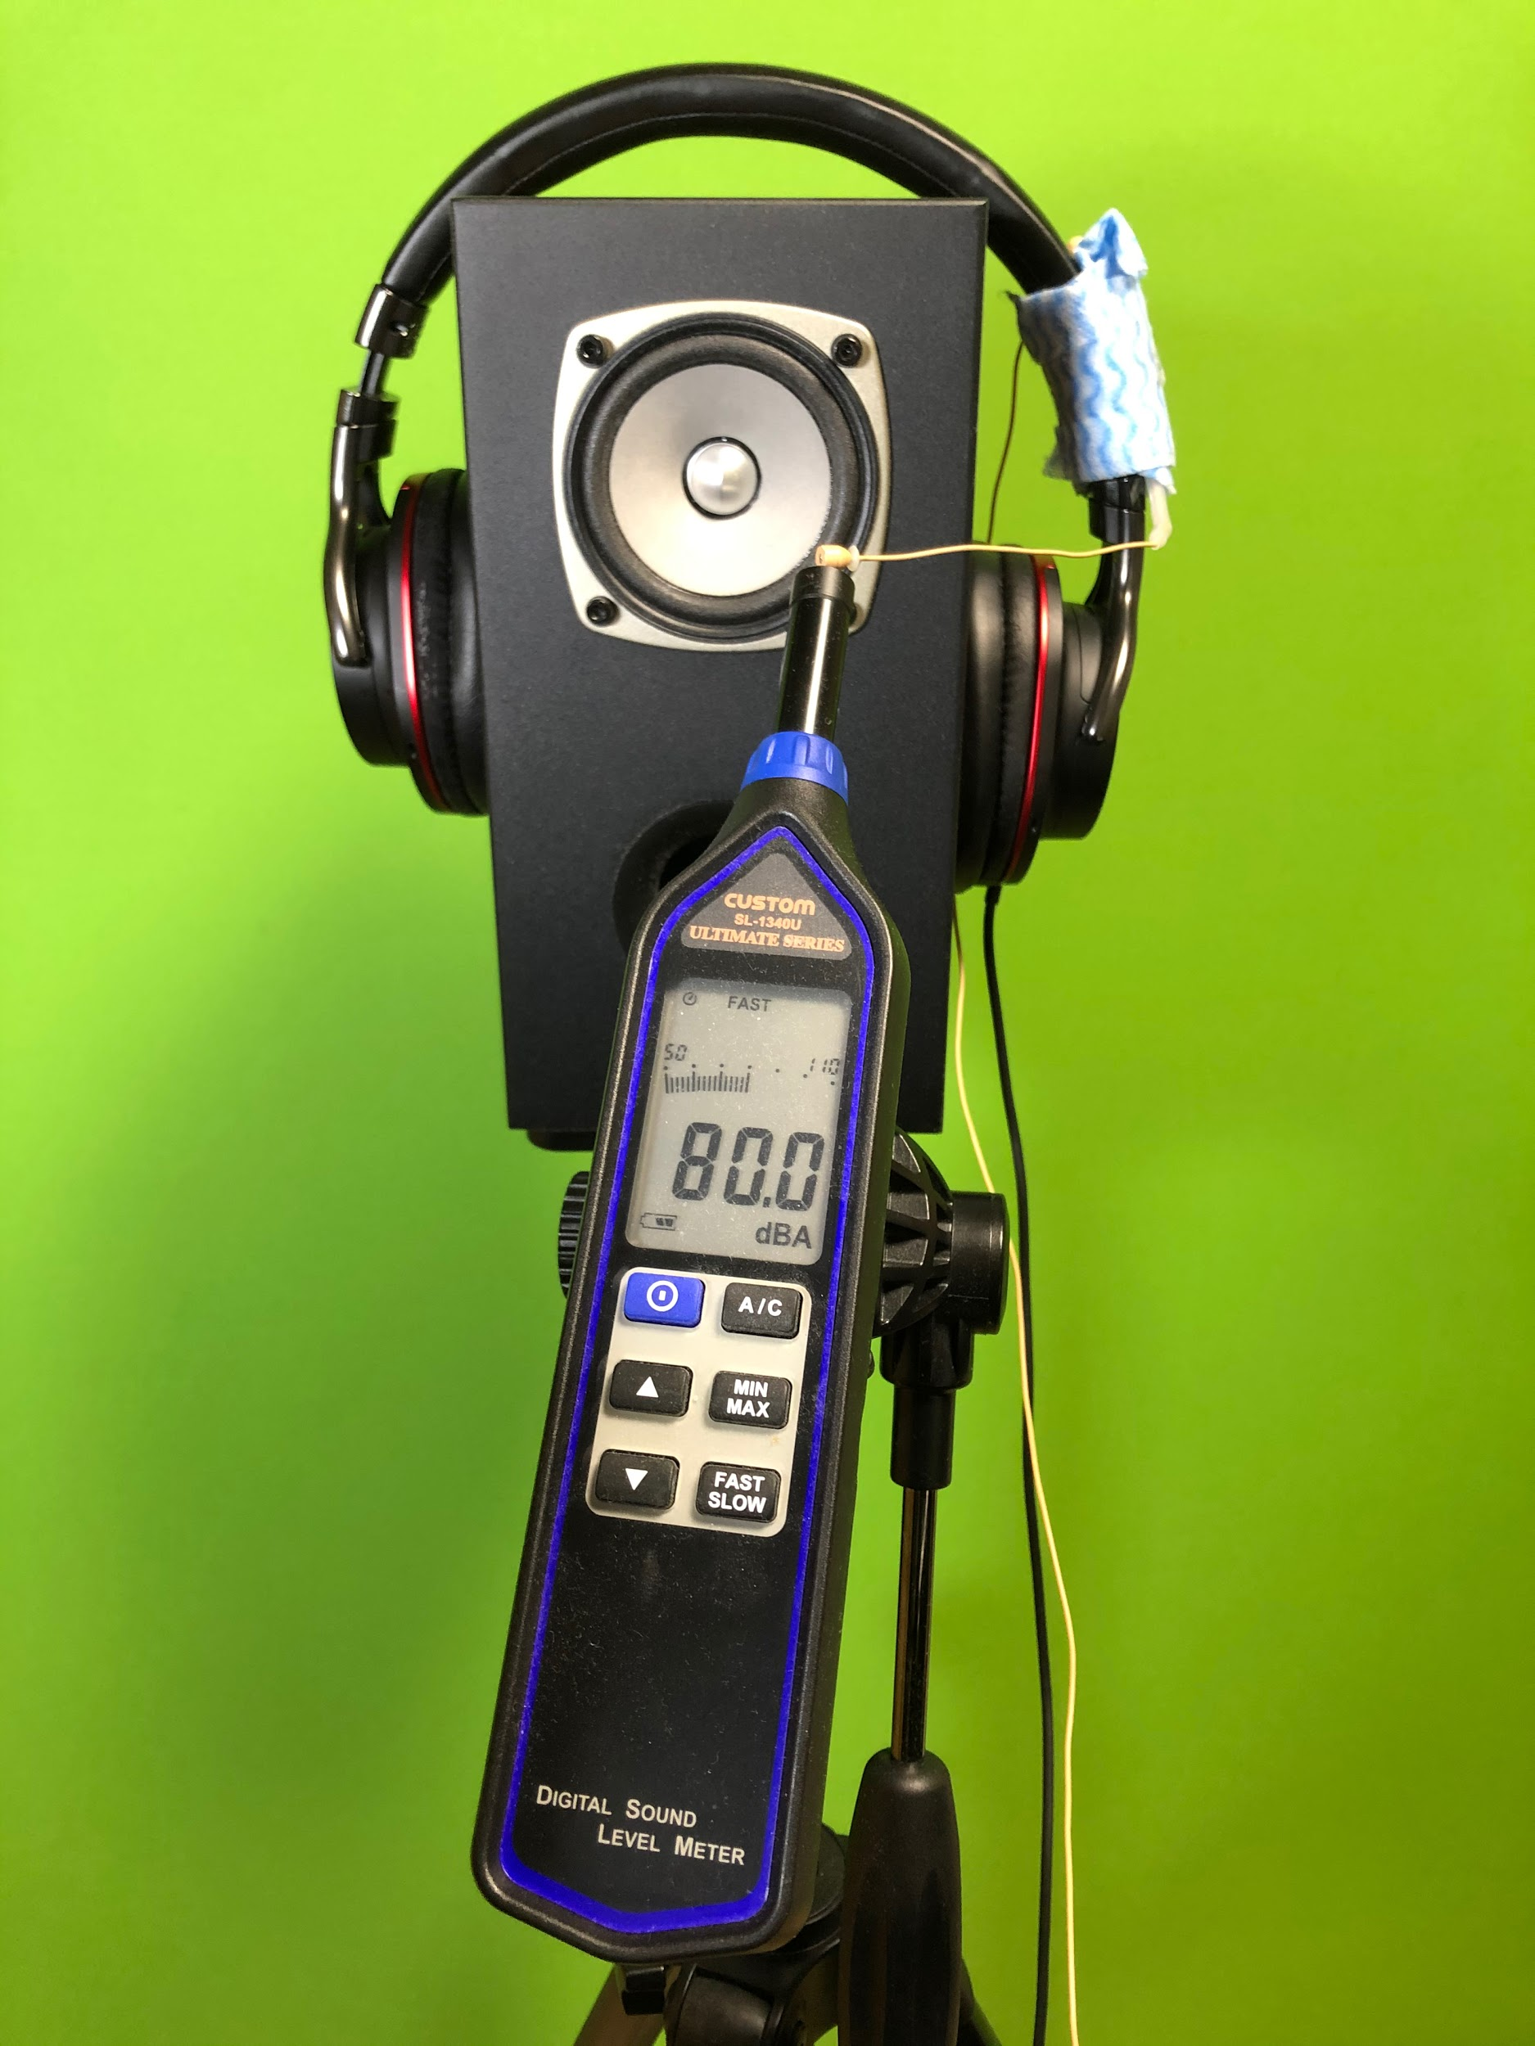

When you have adjusted the sound pressure level to 80dB, press the "80dB" button on the GUI. A little later, a green lamp will light up under 80dB to indicate that the calibration has been completed. Also, under the "RESET" button, a value (107.89dB in this case) is displayed to convert the value of the signal read into MATLAB into the calibrated physical quantity (in this case, 20μPa is 0dB).

#### (Supplement: Bugs)

After watching the movie, I noticed a mistake in the implementation. The buttons that should be operated in this state are "START" and

There are only a few others. However, I forgot to put them in the inactive (disable) state. I will fix it later.

### Cleaning up after calibration

Before the experiment, we need to clean up the calibration. Adjust the "OUTPUT" so that the sound from the speakers is low enough so that it does not interfere with the experiment. The only purpose is for the experimenter to check. After determining the appropriate level, adjust the sensitivity of the 2R input, which was set to the lowest sensitivity. It should be set so that the LED above it glows green. An example of the proper setting is shown in the following picture.



## Measurement of fundamental frequency response

The experiment can be done by putting on headphones and a microphone and speaking out. Here, we will play the same sound from the speaker as we are giving to the headphones to see if the experimental system works properly. Press the "START" button to play the test signal and start the experiment. The subject is instructed, "After you begin to hear the sound, take a deep breath and stretch your voice as far as possible. The duration of the sound is 20 seconds. Do not force the subject to do anything. If they can hold their voice for more than 10 seconds without straining, they are fine.

When the sound finishes, you will see a screen like the one below.

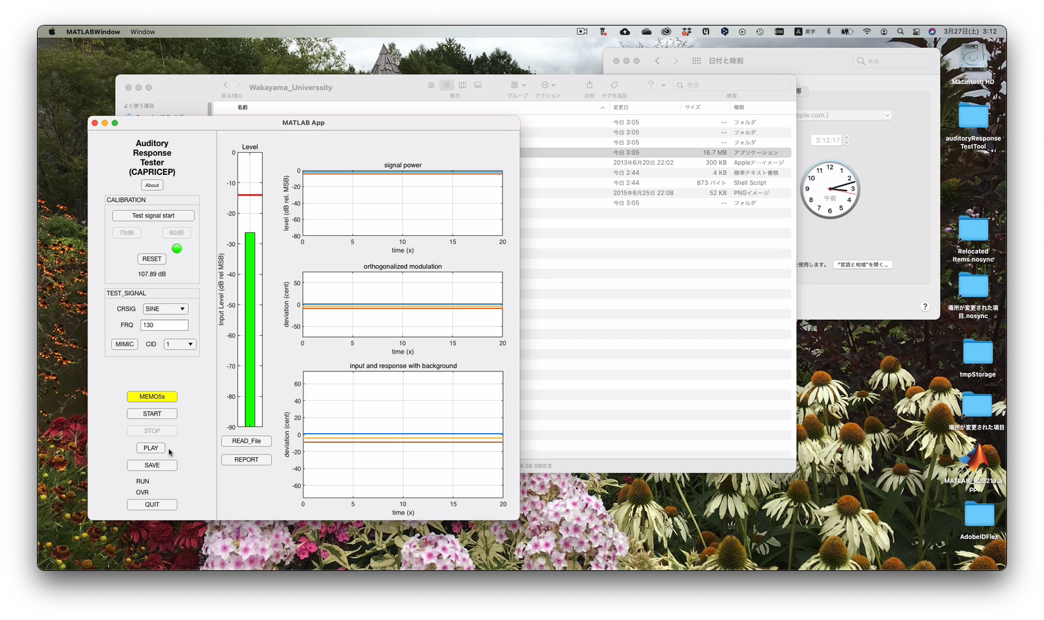

### Record and analyze experimental results

As long as it is not an obvious accident, for example, the voice was cut off due to inability to speak, or the test signal was interrupted in the middle of the test, please click the "SAVE" button to record the recorded voice. Once recorded, the analysis will start. The reason for this procedure is to prevent misconduct in the experiment. The results of the experiment will be recorded with a unique name generated from the time stamp. The results of the experiment are recorded with a unique name generated from the timestamp, and the fact that they were recorded is recorded in the log file along with the file name.

In this movie, instead of the human voice, the same signal as in the headphones was emitted from the speakers and picked up by the microphone. The result was as follows.



The bottom right shows the frequency modulation of the (orthogonalized, organized, and synchronously added) test signal (red solid line) and the frequency modulation of the signal recorded by the microphone (blue solid line). In this case, both lines overlap almost perfectly. This indicates that the experimental system is working correctly.

The upper right graph shows the level of the signal sent out to the headphones and the level of the signal picked up by the microphone. In this experiment, the "OUTPUT" knob was operated while playing sound, so you can see that the sound level changed during the experiment. In this experiment, we are only looking at frequency modulation, so changes in the sound output level will not affect the experimental results.

Now that you have confirmed this, proceed with the experiment.

### Confirmation of presented sound pressure

In this experiment, it is necessary to check the sound pressure to be presented to the subject before the experiment. This should be done by using an artificial ear or HATS, but there is an easy way to check it on the safe side. This method will always give a higher value compared to the use of an artificial ear or HATS. Since the microphone is already calibrated, we can use it to measure the sound pressure in the space created by the headphones and the plane, as shown in the picture. It's a bit rough, but it gives us a safe value. In the case of the Rubix24, the sound level coming out of the headphones can be adjusted using the top right knob.

